MUKONO MUNICIPAL COUNCIL

DOCUMENT MANAGEMENT SYSTEM

USER GUIDE

By
V8 Consultancy Limited

Last updated: April 2026

Table of Contents
1. Introduction. 3
2. How to Login 3
3. Landing Page 4
4. Important setting 4
5. Creating Users 5
6. Creating Document categories 5
7. Creating document 6
7.1 Attaching document 6
8. Forwarding documents 7
9. Writing comments 7
10. Closing a document 8
11. Archiving document 8
12. Backup of Information 9
13. User permissions 10

Introduction.
The system is accessed through
https://documents.mukonomunicipalcouncil.go.ug/
or
https://www.documents.mukonomunicipalcouncil.go.ug/

How to Login
The system does not support creating of accounts, all accounts are created by the Admin.
When your account is created, you receive an email that contains the link to set your password
Then you will always log in with that email and that password. You are encouraged to change your password at most monthly.
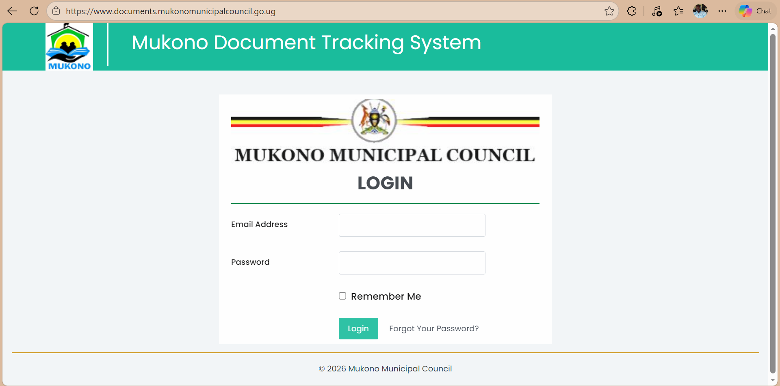

Landing Page
This is a list of documents that you should attend to, those you have already forwarded will nolonger appear on the home page.
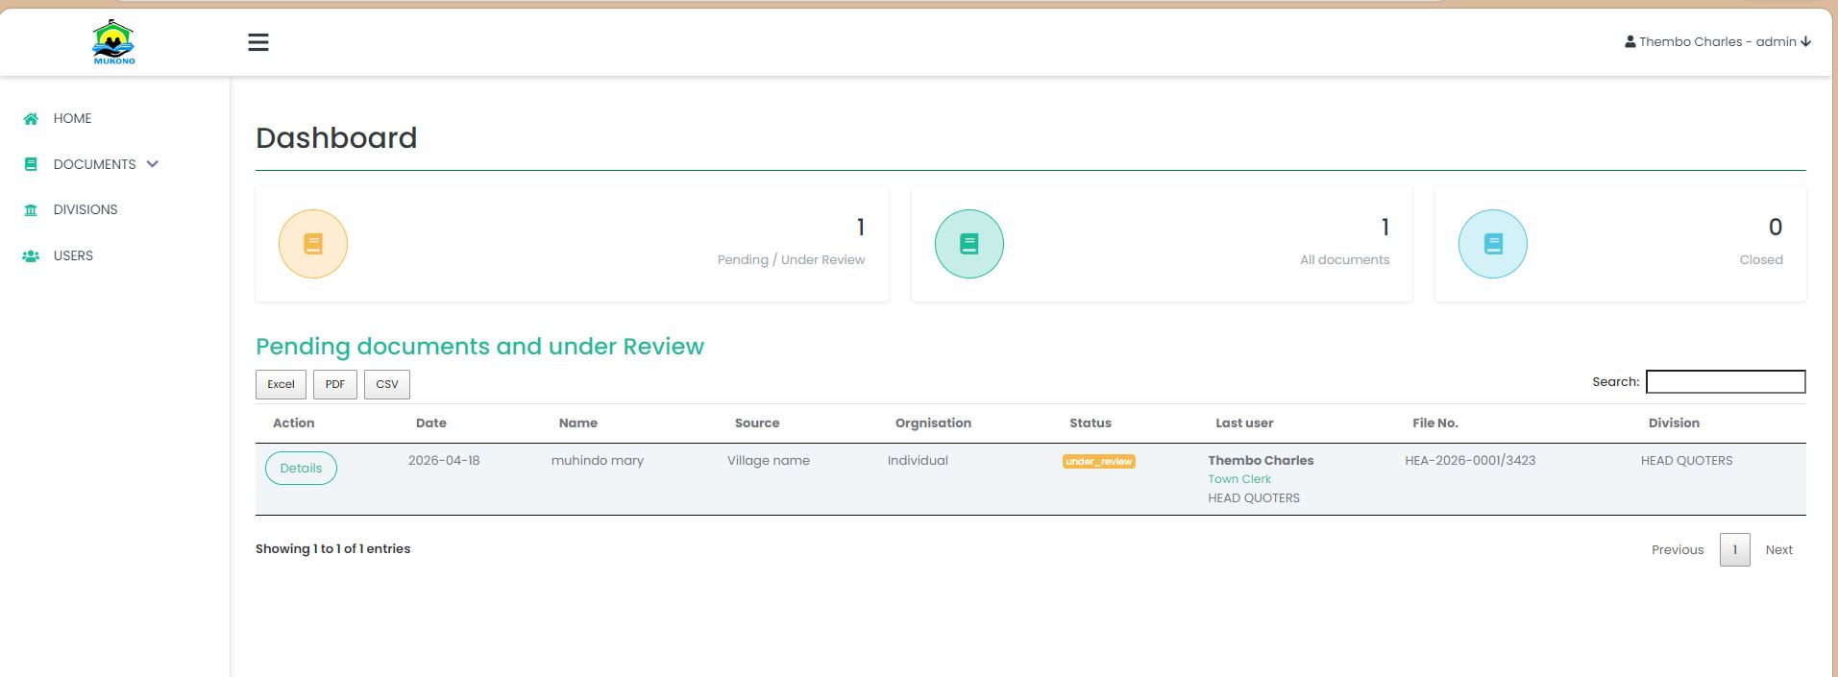

After logging in, you will see the un attended to documents assigned to you.

Important setting
Creating Divisions
Steps
- Click on Divisions
- A list of divisions will show
- Click on the “Create division” button
- This page will display
- Enter division name and Status
NB: Status can be primary or secondary
All users in primary division can send documents to any user in the system.
Users in the secondary division can only send documents to those in primary division and their own division.
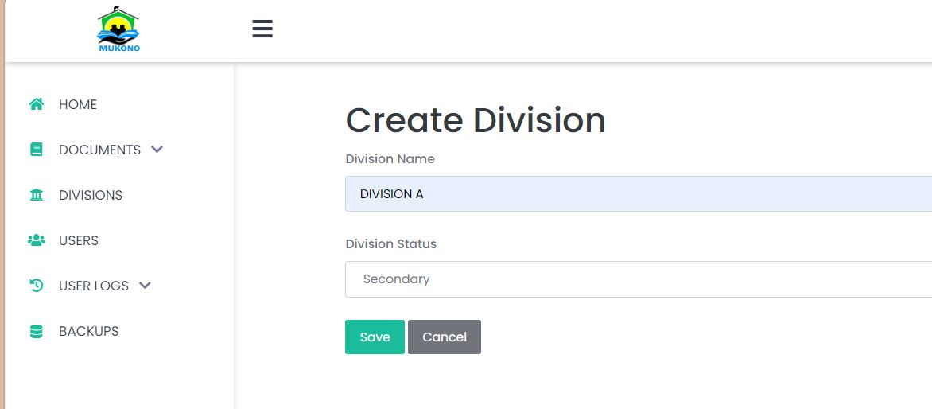

Creating Users
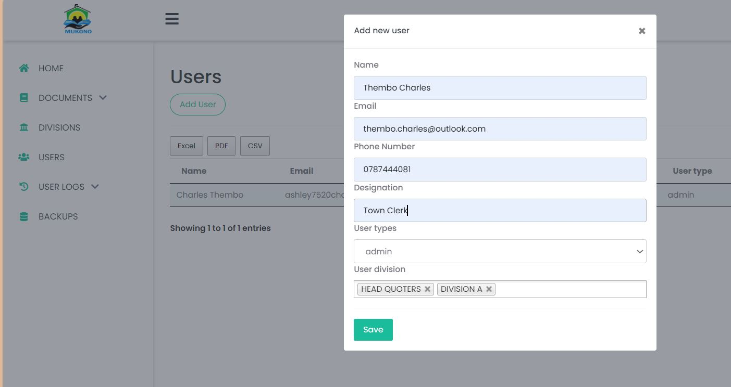

Steps:
- Click on users
- Click on “Add User”
- Fill in the form and save
NB: Ensure you have created divisions

Creating Document categories
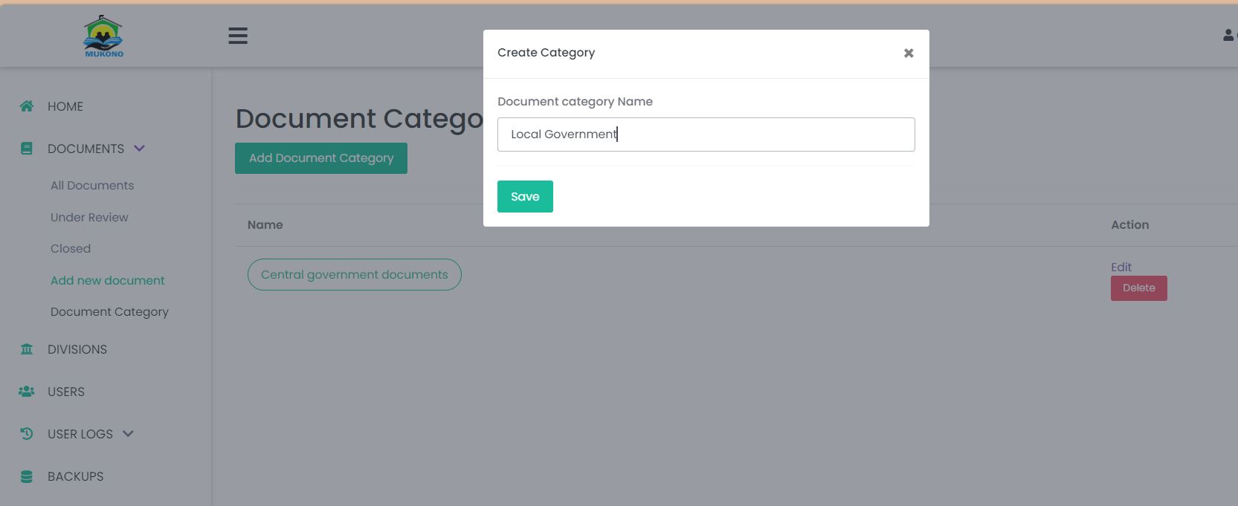

Steps
- Click on Documents
- On the drop-down, click on Document Category
- The List of categories will load in a table
- Click on the “Add Document Category” Button
- The Model will show up
- Write the category name and Save
- NB: All documents MUST be assigned a category

Creating document
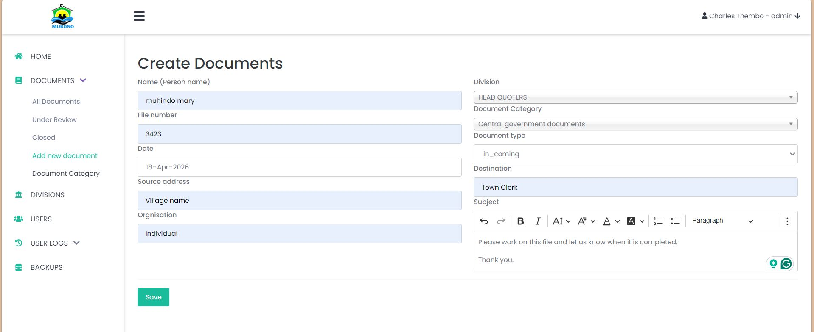
Steps
- Click on documents
- On the drop down, click on “Add New document” item
- The Form will open
- Fill it in and save.

7.1 Attaching document
After you click save the file attachment page will open
Steps
- Scan the documents using the scanner machine (Have those scanned Images on this this device)
- Upload those scanned images and re-arrange them.
- Write the document name
- Click on the “Merge and upload” button.
NB: Only Images are merges and converted to PDF, Excel, word and ODF files are uploaded as is.
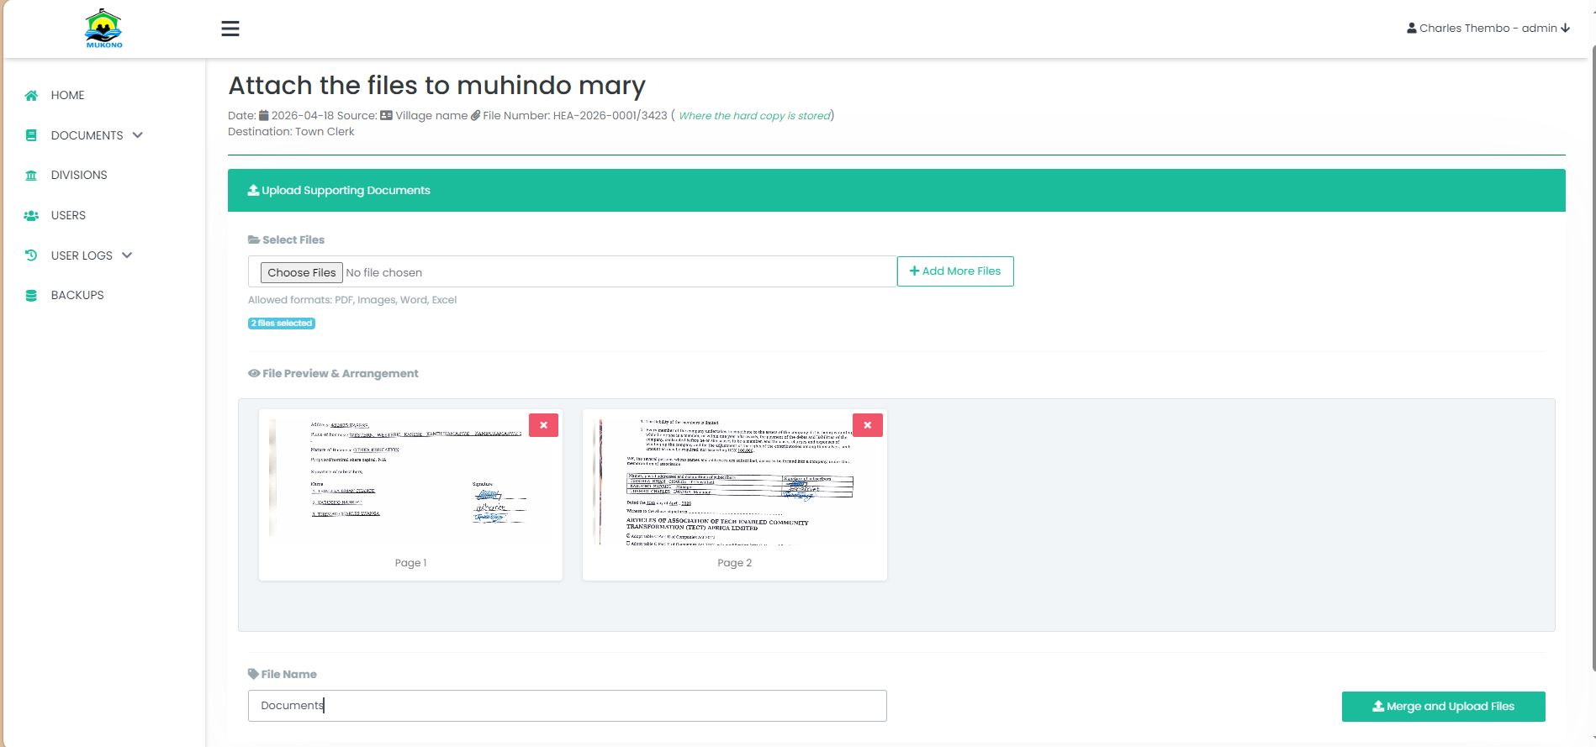

Click here to upload the files

Forwarding documents
If you are in a primary division, you can upload documents to every user in the system.
If you are in a secondary division, you can only forward documents to users in your division and to those in the primary division.
Click here to forward the document
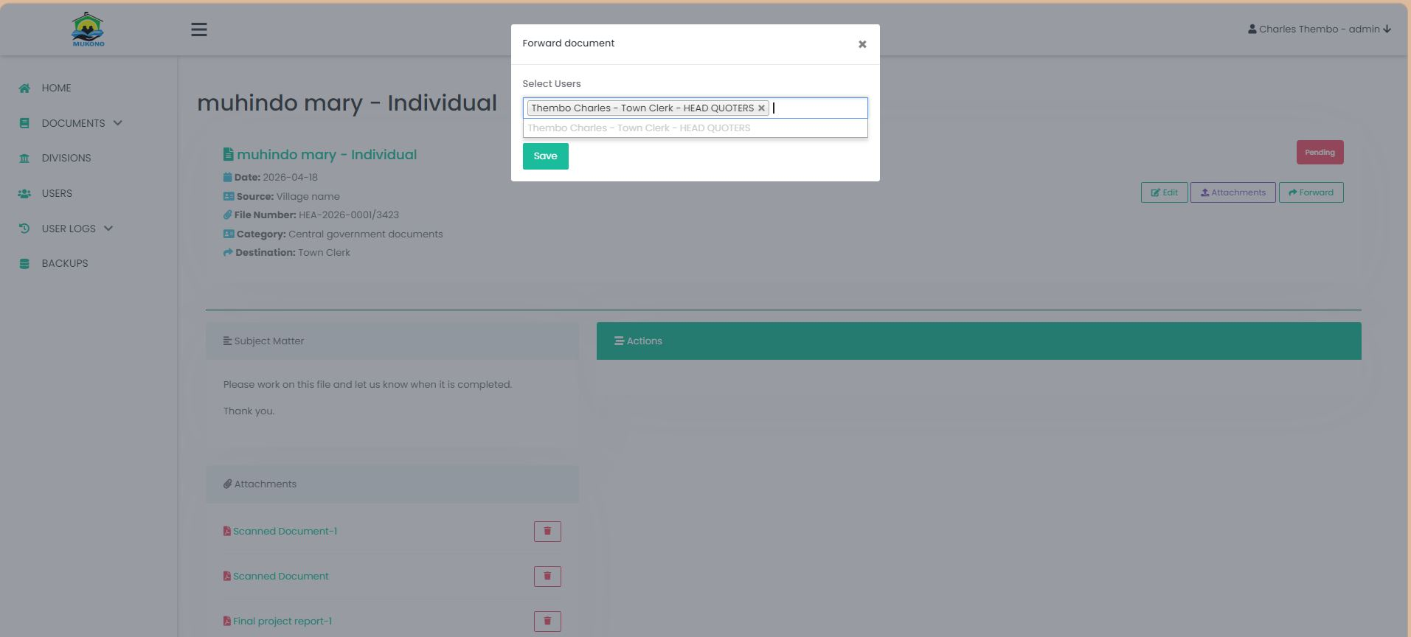

Writing comments
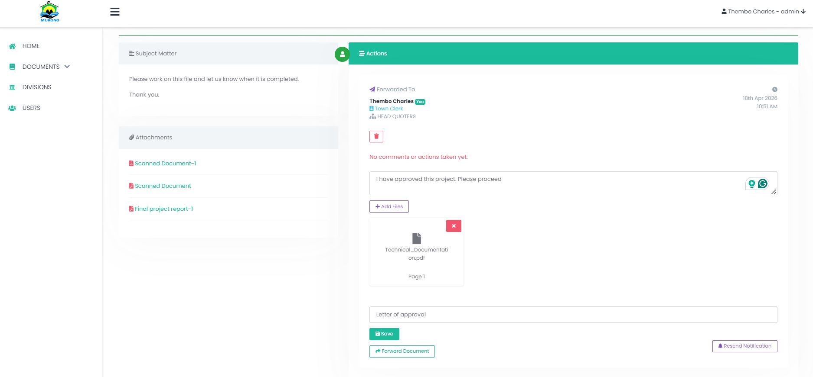

Steps
- On the documents List, click on the “Details” button
- The details page opens
- Write your comment – On the right side
- If you have a file to attach, upload them and
- Click on the same button
Click here to forward the document o the next user

Closing a document
This is only done by the admin user
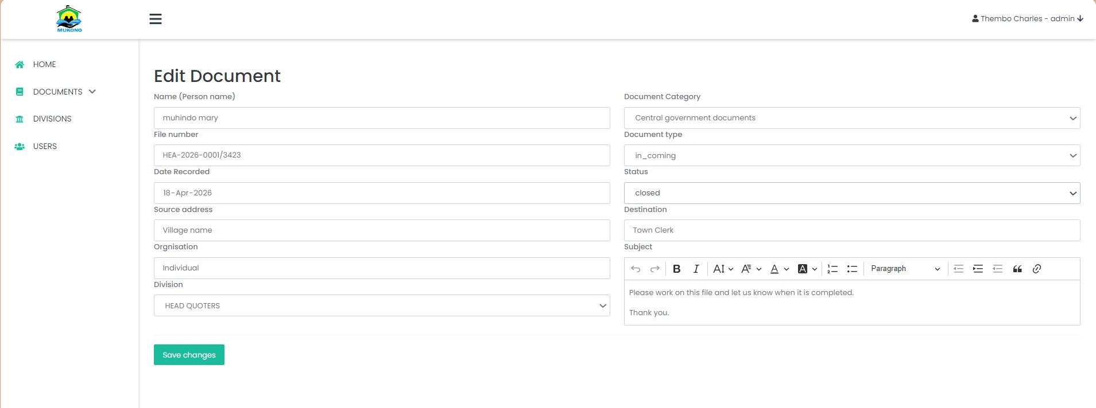

Steps
- Inside the document details, click on “Edit” button (Top right)
- In the edit form that opens, select status “Closed” and then
- Click “Save changes” button.

Archiving document
To archive document, you need to be admin and with a permission to archive documents.
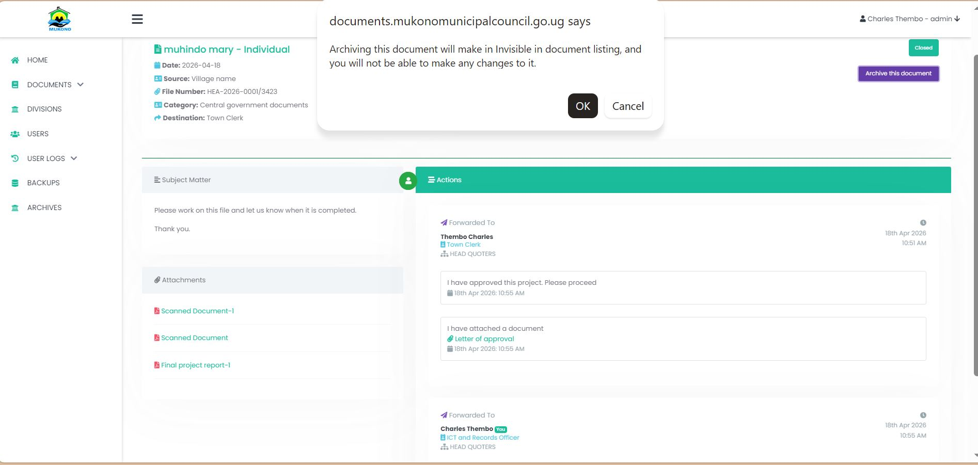

Click Here to archive a document

Backup of Information
Backups happen automatically and the data is uploaded to google cloud, However the user with the back up permission can also access these backups from with in the system.
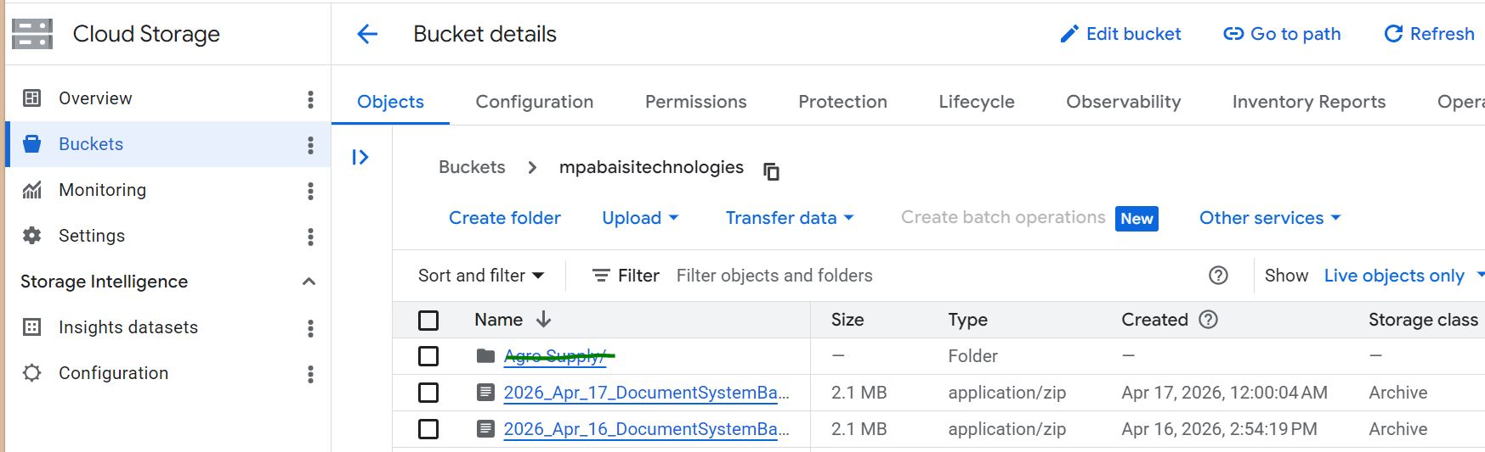

A snap short of the data backed up on google cloud storage.

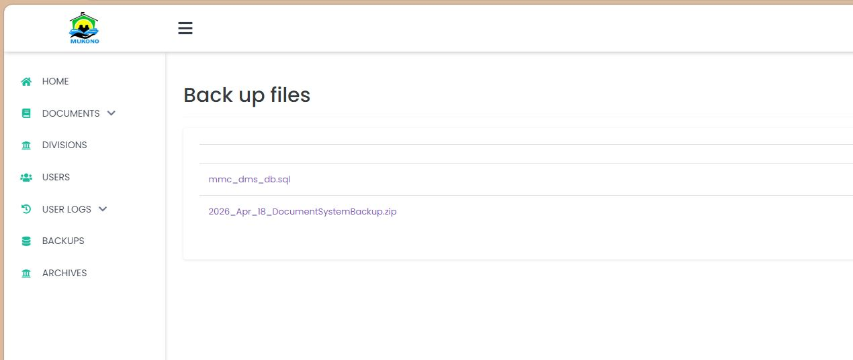

Manual Backups

User permissions
A user can only access modules whose permissions they have.
You assign permissions by click on the box and revoke the permission by un ticking the box.
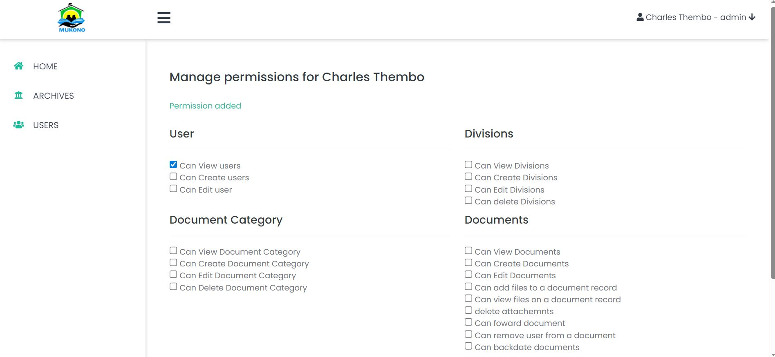

By
Thembo Charles Lwanga
0787444081

